# Bahria University,

## Karachi Campus



LAB EXPERIMENT NO.

**_09_**

LIST OF TASKS

|  |  |
| --- | --- |
| **TASK NO** | **OBJECTIVE** |
| 01 | Write a Python program utilizing Simpson's 3/8 Rule to compute the definite integral 𝟎.𝟖 𝟏 ∫ ( 𝟐 + 𝟐𝟓𝒙 − 𝟐𝟎𝟎𝒙𝟐 + 𝟔𝟕𝟓𝒙𝟑 − 𝟗𝟎𝟎𝒙𝟒 + 𝟒𝟎𝟎𝒙𝟓 ) 𝒅𝒙 where n = 3 represents the number of intervals used in the approximation |
| 02 | Write a python program to determine the approximation of the area beneath the curve represented by y = f(x) using Simpson’s 3/8. The values of the function f(x) are provided within following table |
| 03 | Write a python code in table below to determine the integral for this data: |

Submitted On:

Date: 02/12/2024

**Task No 01:** Write a Python program utilizing Simpson's 3/8 Rule to compute the definite integral 𝟎.𝟖 𝟏 ∫ ( 𝟐 + 𝟐𝟓𝒙 − 𝟐𝟎𝟎𝒙𝟐 + 𝟔𝟕𝟓𝒙𝟑 − 𝟗𝟎𝟎𝒙𝟒 + 𝟒𝟎𝟎𝒙𝟓 ) 𝒅𝒙 where n = 3 represents the number of intervals used in the approximation

**Solution:**

def simpsons_38(func, a, b, n):

    if n % 3 != 0:

        raise ValueError("Number of intervals 'n' must be a multiple of 3 for Simpson's 3/8 Rule.")

    h = (b - a) / n

    x = [a + i * h for i in range(n + 1)]

    f_values = [func(xi) for xi in x]

    integral = f_values[0] + f_values[-1]

    for i in range(1, n):

        if i % 3 == 0:

            integral += 2 * f_values[i]

        else:

            integral += 3 * f_values[i]

    integral *= (3 * h / 8)

    return integral

def f(x):

    return (1 / 2) + 25 * x - 200 * x**2 + 675 * x**3 - 900 * x**4 + 400 * x**5

a = 0  # Lower limit

b = 0.8  # Upper limit

n = 3  # Number of intervals (must be a multiple of 3)

result = simpsons_38(f, a, b, n)

print(f"The approximate integral is: {result}")

**Output:**

**Task No 02:** Write a python program to determine the approximation of the area beneath the curve represented by y = f(x) using Simpson’s 3/8. The values of the function f(x) are provided within following table

**Solution:**

def simpsons_38_table(x, f):

    n = len(x) - 1  # Number of intervals

    if n % 3 != 0:

        raise ValueError("Number of intervals 'n' must be a multiple of 3 for Simpson's 3/8 Rule.")

    h = (x[-1] - x[0]) / n

    integral = f[0] + f[-1]

    for i in range(1, n):

        if i % 3 == 0:

            integral += 2 * f[i]

        else:

            integral += 3 * f[i]

    integral *= (3 * h / 8)

    return integral

x = [1.4, 1.6, 1.8, 2.0, 2.2, 2.4, 2.6]

f = [4.0552, 4.953, 6.0436, 7.3891, 9.025, 10.092, 11.099]

result = simpsons_38_table(x, f)

print(f"The approximate area is: {result}")

**Output:**



**Task No 03:** Write a python code in table below to determine the integral for this data:

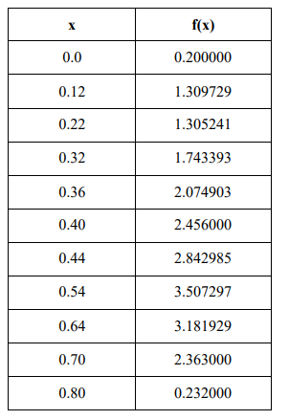

**Solution:**

import numpy as np

x = np.array([0.0, 0.12, 0.22, 0.32, 0.36, 0.40, 0.44, 0.54, 0.64, 0.70, 0.80])

f = np.array([0.200000, 1.309729, 1.305241, 1.743393, 2.074903, 2.456000, 2.842985, 3.507297, 3.181929, 2.363000, 0.232000])

integral = np.trapz(f, x)

print(f"The approximate integral is: {integral}")

**Output:**

